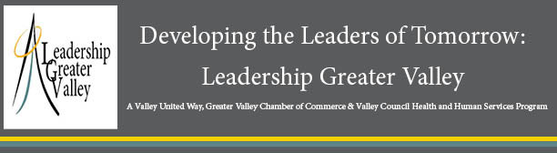

2022 Session Agenda

SESSION 1) QUALITIES OF LEADERSHIP
Thursday, September 22nd – 1:00pm - 5:00pm
Greater Valley Chamber, 10 Progress Drive, Suite 2E, Shelton

SESSION 2) HISTORY OF THE VALLEY
Thursday, September 29th – 12:00 (noon) - 5:00pm
Kellogg Environmental Center/Osbornedale Homestead (Bus Tour), Derby/Valleywide

SESSION 3) MEDIA & COMMUNITY ENGAGEMENT
Thursday, October 6th -- 1:00pm - 5:00pm
Derby Neck Library, Hawthorne Avenue, Derby

SESSION 4) GOVERNMENT AND PUBLIC SERVICE
Thursday, October 13th -- 1:00pm - 5:00pm
Ansonia City Hall

SESSION 5) ECONOMIC DEVELOPMENT AND THE REGION
Thursday, October 20th -- 1:00pm - 5:00pm
Industry Co-Work Space, 415 Howe Avenue, Shelton

SESSION 6) HEALTH AND HUMAN SERVICES
Thursday, October 27th -- 1:00pm - 5:00pm
Griffin Hospital, Dining Room Conference Area, Derby

SESSION 7) DIVERSITY, EQUITY & INCLUSION
Thursday, November 3rd – 1:00pm - 5:00pm
Valley United Way, 54 Grove Street, Shelton

SESSION 8) COMMENCEMENT
Thursday, November 10th – 4:30 pm
Steady Habits, Shelton

*Please note Session Line-up may change due to availability of speakers or locations.

